Simple Seclectors

1. Type Selector

div{

}

2. Class selector

1. class selector starts with .

2. in any html tag we can mention class attribute

<html>

<body>

<div class="sample">

Welcome

<section>kjkjhk</section>

</div>

<p class="sample">

hkkhkhkjhk

</p>

</body>

</html>

.sample{

color:red;

}

2.Id selector

1. class selector starts with .

2. in any html tag we can mention class attribute

<html>

<body>

<div class="sample">

Welcome

<section>kjkjhk</section>

</div>

<p class="sample">

hkkhkhkjhk

</p>

</body>

</html>

.sample{

color:red;

}

Id selectors

<html>

<body>

<div id="heading">

Welcome

<section>kjkjhk</section>

</div>

<p id="content">

hkkhkhkjhk

</p>

</body>

</html>

#content{

color:red;

}

where class can be repeated and id should be uniq

**General Sibling**

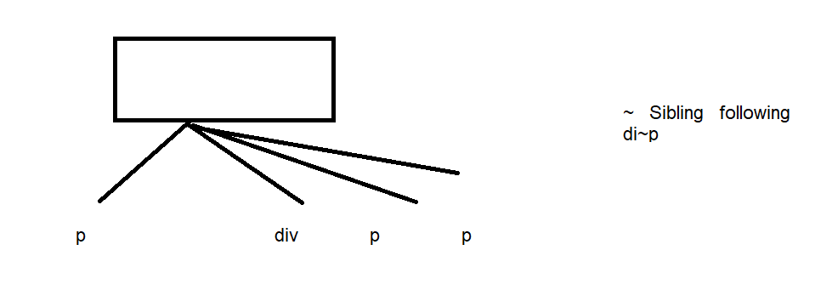

**<html>**

**<body>**

**<p>kjhkj</p>**

**<div id="heading">**

**<p>Welcome</p>**

**<p>mnmn</p>**

**<section>kjkjhk</section>**

**</div>**

**<p>**

**hkkhkhkjhk**

**</p>**

**<p>lkjlk</p>**

**</body>**

**</html>**

**div~p{**

**color:red;**

**}**

**2. Combinator Selectors**

* **Descendant Selector**: Selects all elements that are descendants of a specified element.

div p {

color: green;

}

This will style all <p> elements inside <div> elements.

* **Child Selector**: Selects all elements that are direct children of a specified element.

div > p {

color: red;

}

This will style all <p> elements that are direct children of <div> elements.

**Attribute selector**

a[title]{

color:red

}

<a>Home</a>

<a title="lk">mn</a>

**<html>**

**<body>**

**<ul>**

**<li>1</1i>**

**<li>2</1i>**

**<li>3</1i>**

**<li>4</1i>**

**</ul>**

**</body>**

**</html>**

**li:nth-child(2){**

**color:red**

**}**

**a::hover{**

**}**

**p::before{**

**content:'note'**

**}**

**Where p::before will add note before all <p>**